PBL- Party Planner Project-- As a fourth grade class we will plan a mock party and calculate our budget using addition, subtraction, multiplication and division.

1st product: Invitation to a party

The final product you will create is an invitation to a party you are planning. You will need to decide a theme and who to invite. The amount of people you invite must be an odd number and more than 15 people. Your invitation must have a few key details:
- Like all invitations, it should have a location, date, time, etc.
- The theme must be obvious.
- It must contain at least 2 adverbs.
- It must contain at least 2 adjectives.
- Invitations often have fragmented sentences, but yours must contain 1 complete sentence.
- Your name should be in the invitation somewhere.

2nd product: Planned party document and budget.

The final product will be a document showing what items you are buying, how much you are buying of each item and how much you are spending. The documents necessary to plan your party will be provided. Key details to remember:
- You can’t go over your budget.
- All your guests must receive at least one of any item you buy to give away or eat. So, for example, if you were to buy chocolate chip cookies, then you must buy at least enough to distribute equally to every guest, including yourself. Leftovers or extras are fine.
- You must fill in your budget planner complete and accurately.

3rd product: Diagram of party space

The final product will be a diagram of the party space. You will sketch or draw your proposed party. Details to remember:
- Make sure to draw and label where the tables and chairs will be.
- Make sure to draw and label where any rented fun items will be, i.e. snow cones, bounce house, etc.
- You must tell the area and perimeter of the space you are going to use. Be realistic, please!

This project will take approximately 16 sessions. I write them out as days but multiple sessions could happen on one day. Each session should last around 15-30 minutes depending on the session.

Session 1: Class discussion of what are typical things found at a party are and their typical cost. As a class we will make a master list of what items will be necessary and possible to throw a great party. We will also discuss what is a reasonable budget.

Session 2: Students will create a master list of people for their party and decide on their themes. We will look at invitations and decide on factors that help the invitee know what is going on.

Session 3: We will start on our invitations. If possible, we will create the invitations in computer class. If not, we will create paper invitations.

Session 4: We will discuss budgets in more depth and we will read “Brad needs a budget”.

Session 5: We will watch a short video on budgeting and discuss. https://www.youtube.com/watch?v=pN709oX9Bzk

Session 6: Finish reading “Brad needs a budget” and discuss.

Session 7: Students will do the math picnic activity as a warm-up to the bigger budget activity.

Session 8: Review our picnic activity to gauge understanding. Finish our invitations.

Session 9: Further work on our budgets, with more check ins for understanding.

Session 9: The students will be given the list with all the possible items that could be bought or rented with their prices. They will also be given their budgeting worksheet where they will balance their expenses. Students will start their budgets. We will meet in small groups to check for understanding and to make corrections.

Session 10: Finish up our budgets.

Session 11: 10 minute refresher lesson on perimeter and area and how to diagram. Then we will do a hands on measuring activity where the students will measure and diagram the picnic area. They will draw a smaller version of the item they measured and show the actual measurements; area and perimeter.

Session 12: Finish picnic area diagram activity.

Session 13: Review of the picnic area diagram activity.

Session 14: Start to create diagram of the layout of their party.

Session 15: Another day to work on their layout.

Session 16: Review of the project.

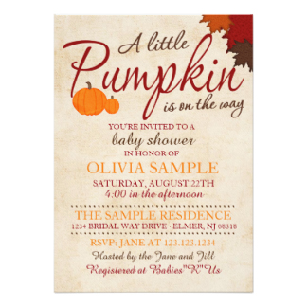

Sample invitations that we will discuss as a class:
